Vel Senthil
Professor Hunt Allcott
GEP 130: Environmental Economics: Models, Data, and Policy Design
Autumn: December 4, 2025

Tamil Nadu Groundwater and Agricultural Yield Analysis

I. Introduction
Groundwater is a critical input into agricultural production across much of India, particularly in semi-arid regions where rainfall is highly variable and surface water storage is limited. Over the past several decades, rapid expansion of irrigated agriculture, combined with subsidized electricity and weak regulation of groundwater extraction, has led to widespread depletion of aquifers (Rodell et al. 2009; Fishman et al. 2015). Tamil Nadu exemplifies these dynamics. Despite relatively high agricultural productivity, the state faces chronic groundwater stress, with many districts extracting groundwater at rates exceeding annual recharge.
At the same time, agricultural outcomes in Tamil Nadu remain strongly linked to climatic conditions, especially monsoon rainfall. Variability in rainfall affects both crop yields directly through soil moisture and indirectly through groundwater recharge. This interaction between rainfall, groundwater availability, and agricultural production raises an important empirical question: to what extent do rainfall fluctuations mitigate or exacerbate the relationship between groundwater stress and agricultural output?
This paper studies the relationship between groundwater extraction stress, rainfall, and agricultural outcomes across districts in Tamil Nadu. Using a newly assembled district-level panel dataset that combines groundwater extraction statistics, high-resolution gridded rainfall data, and crop-specific agricultural production records, I examine how variation in rainfall and groundwater stress correlates with cropped area, output, and yields across major crops.
The analysis proceeds in three steps. First, I document spatial and temporal patterns in groundwater stress and rainfall across districts. Second, I examine descriptive relationships between rainfall, crop yields, and groundwater extraction intensity, with particular attention to crop-specific growing seasons. Third, I outline an empirical strategy that uses district and year fixed effects to isolate within-district variation over time, controlling for unobserved heterogeneity such as soil characteristics and long-run irrigation infrastructure.
This paper contributes to the literature by integrating daily gridded rainfall data aggregated to districts with administrative groundwater extraction measures and crop-level production data, allowing for a detailed examination of how climatic variability interacts with groundwater use in shaping agricultural outcomes at a sub-state level.

II. Literature Review
This paper relates to several strands of the literature on groundwater depletion, agricultural production, and climate variability.
A large body of work documents the extent and consequences of groundwater depletion across India. A more closely related paper, Sekhri (2014), studies groundwater extraction under incomplete property rights and shows that declining groundwater availability reduces agricultural productivity, particularly in regions dependent on private wells. Fishman et al. (2017) further demonstrate that groundwater depletion can lower farm incomes and increase vulnerability to rainfall shocks, reinforcing inequality across farmers and regions.

Recent work has focused explicitly on the interaction between rainfall and groundwater. Giné and Pérez-Foguet (2008) and Fishman (2018) show that rainfall variability affects groundwater recharge and irrigation behavior, with farmers substituting groundwater extraction for rainfall shortfalls. These dynamics imply that rainfall shocks may have heterogeneous effects depending on baseline groundwater conditions.
The paper most closely related to this study is The Impact of Groundwater Depletion on Agricultural Production in Idia (2021), which examines the relationship between sustained groundwater depletion and agricultural outcomes in North India over the period 2004-2013. Using district-level variation in groundwater availability, the authors find that long-run groundwater depletion is associated with declines in both cropped area and crop yields, highlighting the cumulative productivity costs of unsustainable groundwater extraction. While that analysis provides important evidence on long-term depletion effects, it relies on relatively coarse rainfall controls and does not explicitly align rainfall exposure with crop-specific growing seasons.
This paper extends the literature by incorporating high-frequency rainfall data aggregated to crop-relevant seasons and by examining how rainfall interacts with observed groundwater stress across districts. Rather than focusing solely on long-run depletion, the analysis highlights short-run climatic variation as a key mediating factor in agricultural outcomes under groundwater stress.

III. Institutional Background and Policy Context
Groundwater in India is legally treated as an extension of land ownership, granting landowners de facto rights to extract groundwater beneath their land. In Tamil Nadu, as in much of India, groundwater extraction is largely unregulated, particularly for agricultural use. Farmers rely heavily on electric and diesel pumps, with electricity for agriculture often subsidized or free, significantly lowering the marginal cost of extraction.
Tamil Nadu’s agricultural sector is characterized by a mix of monsoon-dependent and irrigated cropping systems. Major crops such as rice, sugarcane, and banana are water-intensive and often rely on groundwater supplementation even during monsoon seasons. Rainfall in the state is bimodal, with contributions from both the retreating southwest monsoon (June–September) and the northeast monsoon (October–December), leading to substantial spatial and temporal heterogeneity in water availability.
To monitor groundwater conditions, the Central Ground Water Board (CGWB) publishes district-level statistics on groundwater recharge, extraction, and the “Stage of Groundwater Extraction,” defined as the ratio of annual extraction to annual recharge, expressed as a percentage. Districts with extraction exceeding 100 percent of recharge are classified as over-exploited.
Despite the availability of these statistics, policy enforcement remains limited. Understanding how rainfall variability interacts with groundwater stress is therefore essential for evaluating the sustainability of current agricultural practices and for informing water management policies.

IV. Data Description
This paper combines groundwater, agricultural production, and rainfall data to construct a district-year panel for Tamil Nadu. All datasets are harmonized at the district level and matched by year, yielding a unified panel that captures variation in water availability, agricultural activity, and climatic conditions across space and time.

Groundwater Data
District-level groundwater statistics are obtained from administrative records published by the Government of Tamil Nadu and the Central Ground Water Board. The primary variable of interest is the Stage of Groundwater Extraction (%), defined as the ratio of total annual groundwater extraction to total annual groundwater recharge. Values above 100 percent indicate that extraction exceeds natural recharge, signaling groundwater overexploitation. The dataset also reports total groundwater recharge, total extraction, and sectoral extraction for irrigation, industrial, and domestic uses, all measured in million cubic meters (MCM).
The analysis focuses on the years 2020, 2022, 2023, and 2024, which provide consistent district-level coverage (with 2021 unavailable). Groundwater stress varies substantially across districts and persists over time. In several districts, extraction substantially exceeds recharge, while others remain below sustainability thresholds. This pronounced heterogeneity motivates the use of district fixed effects to control for time-invariant differences in hydrogeology, irrigation infrastructure, and historical water-use patterns.

Agricultural Production Data
Agricultural outcomes are drawn from district-level Area–Production–Yield (APY) reports published by the Tamil Nadu Department of Agriculture. These data report cropped area (hectares), total production (tonnes), and yield (tonnes per hectare) for major crops. The analysis focuses on seven economically important crops in Tamil Nadu: rice, sugarcane, cotton, banana, coconut, ragi, and bajra.
For each district-year, cropped area and production are aggregated across these seven crops, and an average yield measure is constructed as total production divided by total area. The APY data also include season-specific observations for several crops, which allows agricultural outcomes to be aligned with rainfall during crop-relevant growing periods in crop-specific analyses.

Rainfall Data
Rainfall data come from the India Meteorological Department’s gridded daily rainfall product at a spatial resolution of 0.25 degrees by 0.25 degrees. Daily rainfall rasters are aggregated to district-level averages using area-weighted means based on district boundary polygons. Annual rainfall is computed as the sum of daily rainfall over the calendar year.
To better capture the timing of rainfall relevant for agricultural production, rainfall is additionally aggregated into seasonal measures corresponding to common cropping periods: summer (March–May), kharif (June–September), autumn (October), rabi (November–February), and winter (December–January). These seasonal rainfall aggregates are used in crop-specific analyses, such as rice yields, where rainfall timing plays a critical role in production outcomes.

Summary Statistics and Descriptive Patterns
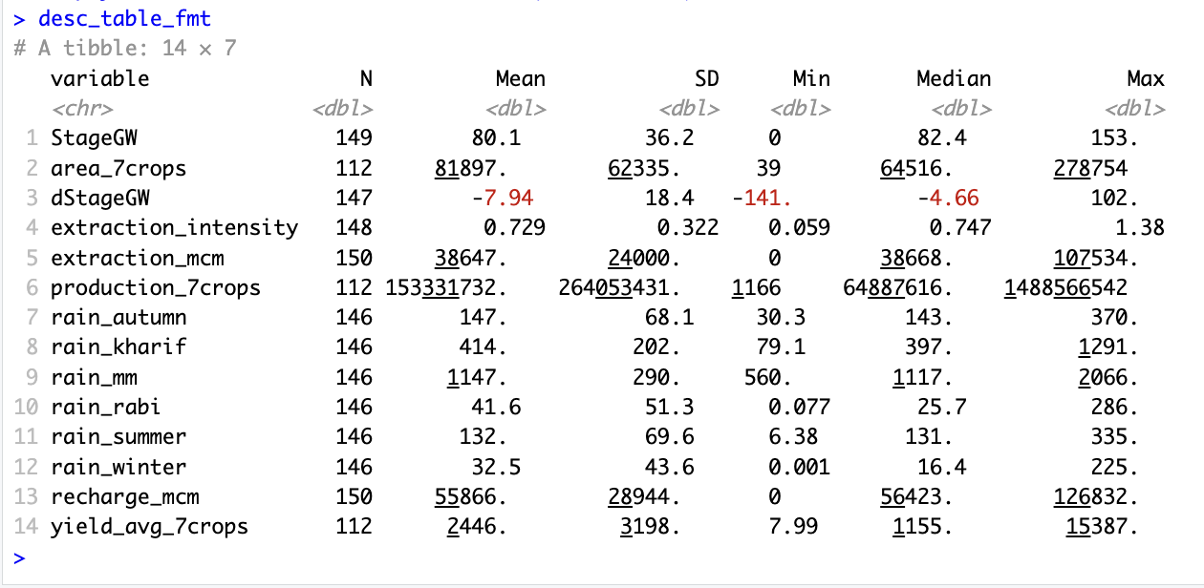
Table 1: Descriptive Statistics Table
Table 1 presents summary statistics for the main variables used in the analysis. Groundwater stress is both high and heterogeneous across districts. The mean stage of groundwater extraction is approximately 80 percent, with a maximum exceeding 150 percent, indicating that several districts extract groundwater far beyond sustainable recharge levels. Agricultural outcomes also vary widely: total cropped area across the seven major crops ranges from fewer than 50 hectares to over 270,000 hectares, while average yields span nearly two orders of magnitude. Rainfall exhibits substantial spatial and temporal variation, with annual rainfall ranging from roughly 560 mm to over 2,000 mm across districts and years.
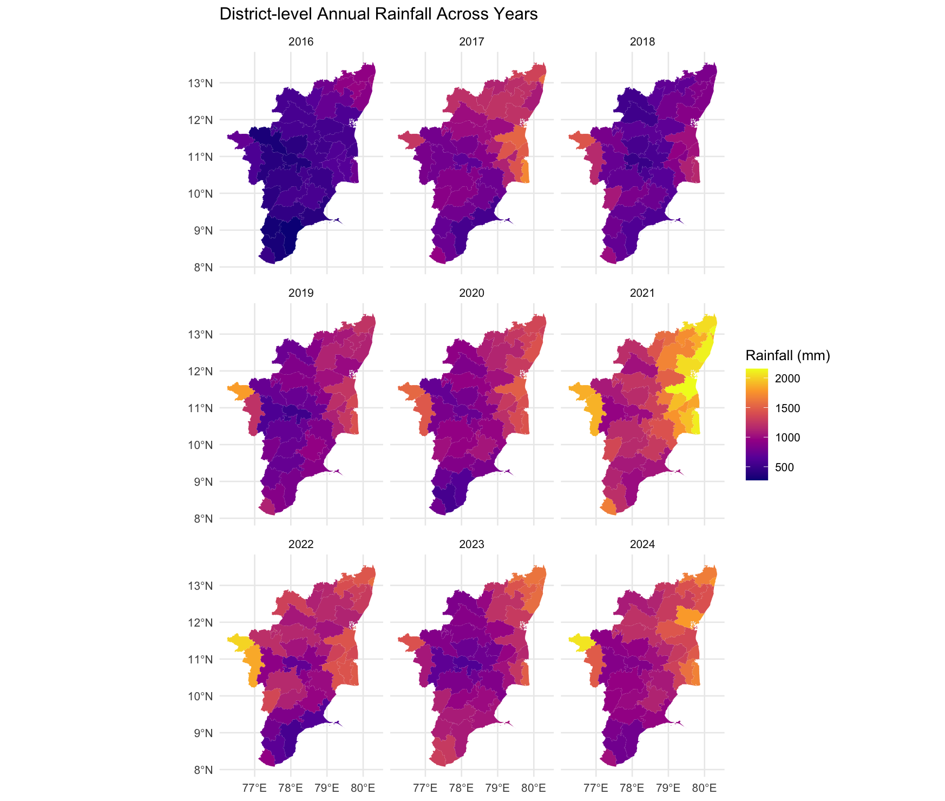
Figure 1: District-level Annual Rainfall Across Years

Figures in this section further illustrate these patterns. Figure 1 presents district-level maps of annual rainfall and shows pronounced spatial gradients, with consistently higher rainfall in coastal and delta regions and lower rainfall in inland districts.
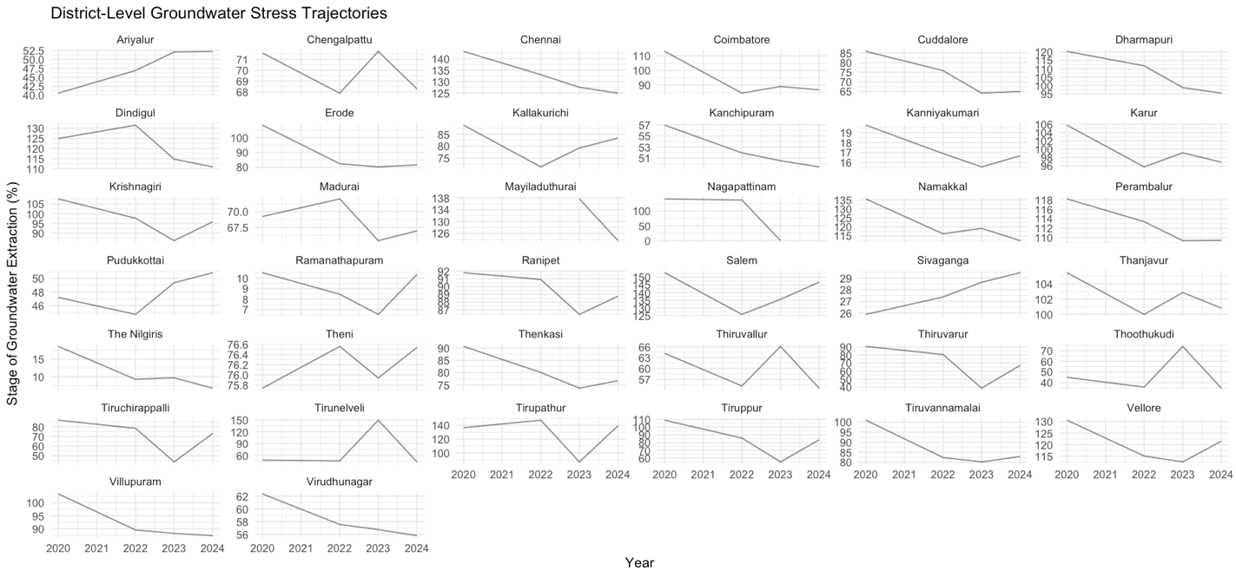
Figure 2: District-level Groundwater Stress Trajectories (2020-2024)

Figure 2 plots the evolution of groundwater stress over time and highlights the persistence of high extraction levels in several districts, alongside limited year-to-year variation. Together, these descriptive patterns motivate the empirical strategy that follows, particularly the inclusion of district fixed effects and rainfall controls. These figures are intended to be descriptive and are not interpreted causally. Notably, Figure 2 indicates that groundwater stress declines in many districts over the sample period, a pattern that contrasts with common narratives of uniformly worsening depletion and motivates a closer examination of how rainfall variation and extraction intensity interact with agricultural outcomes.

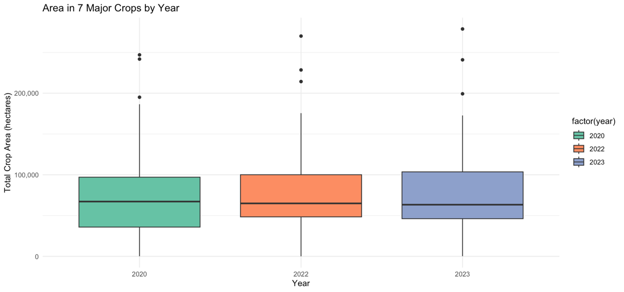
Figure 3: Cropped Area Distribution over Time

Figure 3 presents the distribution of total cropped area across the seven major crops by year. In contrast to the variation observed in groundwater stress, cropped area remains relatively stable over time, with only modest shifts in the median and interquartile range across years. This stability suggests that agricultural land use has not contracted substantially during the sample period, even in districts experiencing high groundwater stress. Taken together with Figure 2, this pattern indicates that recent reductions in measured groundwater stress are unlikely to be driven by large-scale declines in agricultural activity and instead may reflect changes in rainfall-driven recharge, extraction intensity, or adaptive water-use practices.

V. Empirical Strategy
The empirical analysis examines how agricultural outcomes vary with groundwater stress and rainfall across districts and over time. The primary goal is to characterize these relationships while controlling for confounding factors that vary across districts and years.

Baseline Specification
The baseline empirical specification is:

$$Y_{dt}=β_{1}{\text{StageGW}}_{dt}+β_{2}R_{dt}+γ_{d}+δ_{t}+ε_{dt}$$

where $Y_{dt}$ denotes an agricultural outcome in district d and year t, such as total cropped area or average yield across major crops. ${\text{StageGW}}_{dt}$ is the stage of groundwater extraction, and $R_{dt}$ is rainfall, measured either annually or during crop-relevant seasons. The model includes district fixed effects $γ_{d}$ and year fixed effects $δ_{t}$. The coefficients of interest therefore capture within-district changes over time, isolating how deviations from a district’s own historical average groundwater stress and rainfall are associated with changes in agricultural outcomes.
District fixed effects absorb all time-invariant district characteristics, including soil quality, long-run irrigation infrastructure, aquifer properties, and historical cropping patterns. Year fixed effects capture statewide shocks common to all districts, such as changes in crop prices, fertilizer costs, or statewide weather anomalies.
Standard errors are clustered at the district level to account for serial correlation.

Crop-Specific Specifications
For crop-specific analyses, rainfall measures are aligned with the relevant growing seasons. For example, rice yields are related to rainfall during the summer, autumn, and winter periods, which correspond to major rice-growing stages in Tamil Nadu. These specifications take the same general form as the baseline model but replace annual rainfall with seasonal rainfall aggregates tailored to each crop.

Identifying (Causal) Assumption
Although this specification resembles a difference-in-differences design in its use of district and year fixed effects, the analysis does not rely on a discrete treatment or policy shock; instead, identification comes from continuous within-district variation in groundwater stress and rainfall over time, making this a fixed-effects panel design rather than a canonical DiD. The identifying assumption underlying this empirical strategy is that, conditional on district fixed effects, year fixed effects, and observed rainfall, within-district changes in groundwater stress are uncorrelated with unobserved shocks to agricultural outcomes. In other words, after controlling for time-invariant district characteristics and common year-specific shocks, changes in groundwater extraction intensity are assumed not to be systematically related to omitted factors that independently affect agricultural production.
Equivalently, this assumption implies a parallel-trends-type condition: absent changes in groundwater extraction intensity, agricultural outcomes within a district would have followed similar trends over time. Under this assumption, the estimated coefficients capture how deviations from a district’s own historical groundwater stress and rainfall levels are associated with changes in cropped area and yields.
While this assumption cannot be tested directly, it is supported by two features of the empirical design. First, rainfall variation is plausibly exogenous at the district-year level and is explicitly controlled for in the regressions. Second, district fixed effects absorb slow-moving structural factors such as soil quality, aquifer characteristics, irrigation infrastructure, and historical cropping patterns. Nevertheless, given the observational nature of the data and the potential for reverse causality or measurement error, the results are interpreted as conditional relationships rather than definitive causal estimates.

VI. Results

6.1 Baseline Fixed-Effects Results
Given widespread concern about groundwater depletion, one might expect increases in groundwater stress to be associated with declining agricultural area and productivity. Table 2 shows that this relationship does not appear strongly in short-run within-district variation.
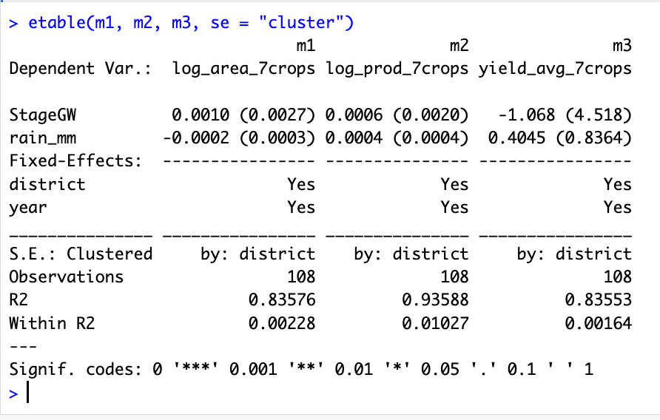
Table 2: Groundwater Stress, Rainfall, and Agricultural Outcomes
Table 2 reports district fixed-effects regressions relating agricultural outcomes to groundwater stress and rainfall. Columns (m1) and (m2) examine agricultural scale, measured by total cropped area and total production across seven major crops, while Column (m3) examines average yield. All specifications include district and year fixed effects, and standard errors are clustered at the district level.
Across all three specifications, the estimated coefficient on groundwater stress is small in magnitude and statistically insignificant. This indicates that within-district changes in the stage of groundwater extraction are not strongly associated with short-run changes in cropped area, total production, or average yields once time-invariant district characteristics and common year shocks are controlled for. Despite widespread concern about groundwater depletion, the regression results do not show evidence of a contemporaneous decline in agricultural outcomes associated with increases in measured groundwater stress over the sample period.
Rainfall enters positively in all specifications, although the estimates are imprecise. A one standard deviation increase in annual rainfall (approximately 290 millimetres) is associated with a 5.8 percent decrease in cropped area, an 11.6 percent increase in total agricultural production, and an increase of roughly 117 units in average yield, though none of these estimates are statistically significant at conventional levels. The positive association between rainfall and production and yield, combined with the absence of an area response, suggests that short-run rainfall shocks primarily affect agricultural output through productivity gains on existing land rather than through expansion of cultivated area.
The high overall R-squared values reflect the importance of district fixed effects in explaining cross-sectional differences in agricultural activity across Tamil Nadu. In contrast, the low within R-squared values indicate that short-run within-district variation explains only a limited share of total outcome variation, consistent with agricultural production being shaped by slow-moving structural factors.

6.2 Groundwater Stress Trends and Agricultural Stability
Figure 2 plots district-level trajectories of groundwater stress from 2020 to 2024. Contrary to common narratives of uniformly worsening groundwater depletion, groundwater stress declines in many districts over the sample period. While several districts remain above sustainable extraction thresholds, the overall pattern suggests stabilization or modest improvement rather than continued deterioration.
Figure 3 complements this finding by showing the distribution of total cropped area across districts over time. Despite substantial heterogeneity across locations, the median and interquartile range of cropped area remain relatively stable across years. This stability indicates that agricultural land use has not contracted substantially during the sample period, even in districts experiencing historically high groundwater stress.
Taken together, Figures 2 and 3 suggest that declining groundwater stress has not been driven by large-scale reductions in agricultural activity. Instead, agricultural scale appears resilient over the sample period, aligning with the regression results in Table 2, which show no strong within-district relationship between changes in groundwater stress and cropped area.

6.3 Rainfall, Yield, and Crop-Specific Patterns
Figure 1 documents substantial spatial and temporal variation in annual rainfall across Tamil Nadu, with consistently higher rainfall in coastal and delta districts than in inland regions. This heterogeneity underscores the importance of controlling for rainfall when examining agricultural outcomes. Scatter plots of annual rainfall against average agricultural yield reveal weak but generally positive associations, particularly in years with favorable monsoon conditions. Although these relationships are noisy and statistically imprecise, they suggest that short-run fluctuations in agricultural productivity are more closely linked to rainfall variability than to contemporaneous changes in groundwater stress.
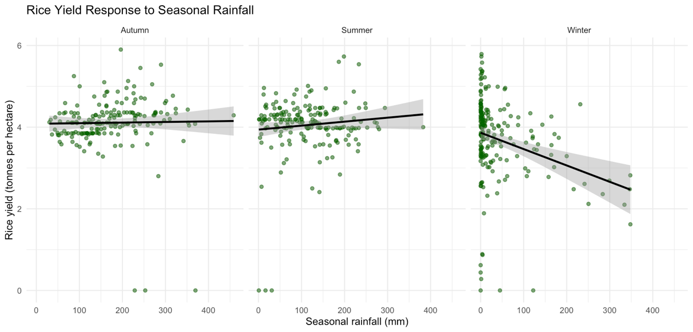
Figure 4: Rice Yield Response to Seasonal Rainfall
To better capture the role of rainfall timing, crop-specific analyses align rainfall with relevant growing seasons. Rice is particularly well suited for this analysis because it is cultivated across multiple seasons in Tamil Nadu and is observed with season-specific yield data over multiple years. Figure 4 plots district-level rice yields against seasonal rainfall during the summer, autumn, and winter growing periods, pooling observations across years.
Rainfall during the summer and autumn seasons exhibits a weakly positive association with rice yields, consistent with the importance of water availability during planting and early vegetative growth. In contrast, winter rainfall is negatively associated with yields, suggesting that excess rainfall during later stages of cultivation may be detrimental, potentially due to lodging, pest pressure, or harvest disruptions. Although these seasonal relationships are not statistically significant at conventional levels, their signs and magnitudes are economically intuitive and consistent with agronomic mechanisms.
These opposing seasonal effects help explain why regressions using annual rainfall yield imprecise estimates: aggregating rainfall over the calendar year obscures meaningful variation in rainfall timing that is critical for crop productivity. Taken together, the crop-specific evidence reinforces the interpretation that short-run agricultural productivity in Tamil Nadu is more sensitive to the timing of rainfall than to contemporaneous variation in measured groundwater extraction intensity.

6.4 Interpretation and Limitations
Overall, the results indicate that agricultural production in Tamil Nadu has remained relatively stable despite persistently high levels of groundwater stress. One possible explanation is that farmers adjust along margins not captured by aggregate area or yield measures, such as crop choice, irrigation efficiency, or input use. In addition, favourable rainfall in parts of the sample period may have partially offset groundwater constraints by supporting recharge and reducing reliance on extraction.
These findings should be interpreted with caution. The analysis captures short-run within-district variation over a limited time horizon and may not reflect longer-run impacts of sustained groundwater depletion. District-level aggregation may also mask heterogeneous farm-level effects, particularly among smallholders. Moreover, groundwater extraction may respond endogenously to anticipated rainfall or policy interventions, potentially attenuating estimated effects. As a result, the estimates are best interpreted as conditional short-run relationships rather than definitive evidence about the long-run sustainability of groundwater-dependent agriculture.

VII. Conclusion and Discussion
This paper examines the relationship between groundwater stress, rainfall, and agricultural outcomes across districts in Tamil Nadu using a newly assembled district-year panel combining administrative groundwater statistics, high-resolution gridded rainfall data, and crop-level agricultural production records. Motivated by concerns over widespread groundwater depletion in India, the analysis initially hypothesized that rising groundwater stress would be associated with declining agricultural area and productivity. Instead, the results reveal a more nuanced pattern.
Despite persistently high levels of groundwater extraction in many districts, agricultural scale and productivity have remained broadly stable over the period 2020–2024. Fixed-effects regressions show no statistically significant association between within-district changes in groundwater stress and total cropped area, agricultural production, or average yields in the short run. At the same time, rainfall (particularly when aligned with crop-relevant growing seasons) appears more closely linked to short-run variation in agricultural productivity. Crop-specific evidence for rice highlights that rainfall timing matters: rainfall during early and mid-season growing periods is weakly positively associated with yields, while excess rainfall during later stages may be detrimental.
These findings suggest that, over the short-time horizon studied, farmers in Tamil Nadu are able to buffer fluctuations in groundwater stress through existing irrigation infrastructure and adaptive practices, such as reallocating water across crops or seasons. Rainfall shocks, by contrast, directly affect soil moisture and crop growth during critical periods and therefore exert a more immediate influence on yields. The observed decline in groundwater stress in several districts, coupled with relatively stable cultivated area, further indicates that recent changes in groundwater conditions are unlikely to be driven by large-scale contractions in agricultural activity.
A broader interpretation of these patterns is that agriculture in Tamil Nadu may be undergoing gradual structural adjustment rather than abrupt decline. Over the past two decades, Tamil Nadu has experienced rapid industrialization and urban expansion, with manufacturing and services accounting for a growing share of economic output and employment (Government of Tamil Nadu, 2021). Industrial growth can influence groundwater outcomes through multiple channels, including changes in water demand, shifts in land use, and public investments in infrastructure and regulation. While the present analysis does not explicitly model industrial activity, the stability of agricultural area alongside declining groundwater stress is consistent with a setting in which pressures on water resources are evolving due to broader economic transformation rather than agricultural contraction alone.
Several limitations of the analysis warrant caution in interpretation. First, the panel covers a relatively short time span and is therefore ill suited to detecting the long-run productivity effects of sustained groundwater depletion documented in earlier studies. Second, groundwater extraction may respond endogenously to expected rainfall or unobserved policy interventions, potentially attenuating estimated relationships. Third, aggregate district-level measures may mask important within-district adjustments, such as crop switching, changes in irrigation efficiency, or heterogeneous impacts across farmers.
Future research could extend this analysis in several directions. Incorporating longer time series data would allow for a clearer distinction between short-run buffering and long-run depletion effects. Explicitly modelling industrial water use, urban expansion, or policy interventions could shed light on how economic transformation interacts with groundwater dynamics. Finally, linking groundwater stress to distributional outcomes, such as farmer incomes or crop choice, would provide a richer understanding of the welfare implications of water scarcity in a rapidly industrializing economy.
Overall, this study highlights that short-run agricultural outcomes in Tamil Nadu are shaped more by rainfall variability and its timing than by contemporaneous changes in measured groundwater stress. While this resilience may obscure the immediate consequences of overextraction, it should not be interpreted as evidence that groundwater depletion is benign. Rather, the findings underscore the importance of proactive water management policies that account for both climatic variability and long-run sustainability in the context of ongoing economic and industrial change.

References
- Central Ground Water Board. (2020). Dynamic groundwater resources of India. Ministry of Jal Shakti, Government of India. https://cgwb.gov.in/Resources/Dynamic-Ground-Water-Resources-2020.pdf
- Central Ground Water Board. (2022). Groundwater year book – Tamil Nadu and Puducherry. Ministry of Jal Shakti, Government of India. https://cgwb.gov.in/GroundWater/GW_YearBook.aspx
- Fishman, R., Siegfried, T., Raj, P., Modi, V., & Lall, U. (2011). Over-extraction from shallow bedrock versus deep alluvial aquifers: Reliability versus sustainability considerations for India’s groundwater irrigation. Water Resources Research, 47(6). https://doi.org/10.1029/2011WR010617
- Giné, X., & Pérez-Foguet, A. (2008). Sustainability of groundwater irrigation: The role of water pricing and institutions in India. World Development, 36(10), 1768–1785. https://doi.org/10.1016/j.worlddev.2007.09.004
- India Meteorological Department. (2023). High resolution gridded daily rainfall data (0.25° × 0.25°). Government of India. https://www.imdpune.gov.in/Clim_Pred_LRF_New/Grided_Data_Download.html
- Mukherji, A., Shah, T., & Giordano, M. (2012). Managing energy–irrigation nexus in groundwater-dependent agriculture: A case study from India. Energy Policy, 49, 601–610. https://doi.org/10.1016/j.enpol.2012.06.038
- Sekhri, S. (2014). Wells, water, and welfare: The impact of access to groundwater on rural poverty and conflict. American Economic Journal: Applied Economics, 6(3), 76–102. https://doi.org/10.1257/app.6.3.76
- Shah, T. (2009). Taming the anarchy: Groundwater governance in South Asia. Resources for the Future Press. https://www.rff.org/publications/books/taming-the-anarchy/
- Shah, T., Burke, J., & Villholth, K. (2007). Groundwater: A global assessment of scale and significance. Water for Food, Water for Life: A Comprehensive Assessment of Water Management in Agriculture. Earthscan. https://www.iwmi.cgiar.org/Publications/Books/PDF/water_for_food_water_for_life.pdf
- Tamil Nadu Department of Agriculture. (2023). Area, production and yield statistics (APY reports). Government of Tamil Nadu. https://data.desagri.gov.in/website
- India Meteorological Department. (2016–2024). High-resolution gridded daily rainfall data for India (0.25° × 0.25°) [NetCDF files]. Ministry of Earth Sciences, Government of India. https://www.imdpune.gov.in/cmpg/Griddata/Rainfall_25_NetCDF.html
- Datta, A. (n.d.). Tamil Nadu district boundaries (GeoJSON). GitHub repository: INDIAN-SHAPEFILES. https://github.com/datta07/INDIAN-SHAPEFILES/blob/master/STATES/TAMIL%20NADU/TAMIL%20NADU_DISTRICTS.geojson
- Directorate of Economics and Statistics, Tamil Nadu. (n.d.). Area, production, and yield (APY) statistics by crop and district. Government of Tamil Nadu. https://data.desagri.gov.in/website/crops-apy-report-web
- OpenCity. (2020). Tamil Nadu groundwater availability, utilization, and extraction—2020. National Compilation on Dynamic Ground Water Resources of India. https://data.opencity.in/dataset/national-compilation-on-dynamic-ground-water-resources-of-india-2020/resource/tamil-nadu-groundwater-availability-utilization-and-extraction-at-states-level-2020
- OpenCity. (2022). Tamil Nadu groundwater availability, utilization, and extraction—2022. National Compilation on Dynamic Ground Water Resources of India. https://data.opencity.in/dataset/national-compilation-on-dynamic-ground-water-resources-of-india-2022/resource/tamil-nadu-ground-water-availability-utilization-and-extraction—2022
- OpenCity. (2023). Tamil Nadu groundwater availability, utilization, and extraction—2023. National Compilation on Dynamic Ground Water Resources of India. https://data.opencity.in/dataset/national-compilation-on-dynamic-ground-water-resources-of-india-2023/resource/ae6c22ab-5cdc-457e-b67e-1dcb37dfb9e8
- OpenCity. (2024). Tamil Nadu groundwater availability, utilization, and extraction—2024. National Compilation on Dynamic Ground Water Resources of India. https://data.opencity.in/dataset/national-compilation-on-dynamic-ground-water-resources-of-india-2024/resource/tamil-nadu-groundwater-availability-utilization-and-extraction-2024
- Government of Tamil Nadu. (2021). Tamil Nadu industrial policy 2021. Industries Department, Government of Tamil Nadu. https://www.tn.gov.in/documents/industrial-policy-2021

