Vel Senthil
Professor Erik Sperling
EPS 271: Mining and the Green Transition
Autumn: December 4, 2025
Long Term Community Value from Carbon Mineralization at Nickel Mines

I. Introduction
Decarbonizing the global economy requires rapid deployment of metal intensive infrastructure, including batteries, electrified transport, and expanded power grids. Yet, mining expansion brings persistent risks for nearby communities and ecosystems, particularly through long lived mine waste such as tailings. A promising approach for aligning the energy transition with stronger environmental stewardship is to treat certain mine wastes not only as liabilities, but also as durable carbon dioxide removal infrastructure.
Nickel mines that process ultramafic rocks can generate tailings rich in magnesium bearing minerals that naturally react with atmospheric carbon dioxide to form stable solid carbonates, effectively storing carbon for very long-time periods. This process, known as mineral carbonation, converts carbon dioxide into minerals such as hydro-magnesite and magnesite, providing storage durability on the order of thousands of years (Wilson et al., 2014). Because this carbonation occurs in materials that are already excavated, crushed, and stored at large scale, it represents a form of direct air capture embedded within existing mining operations.
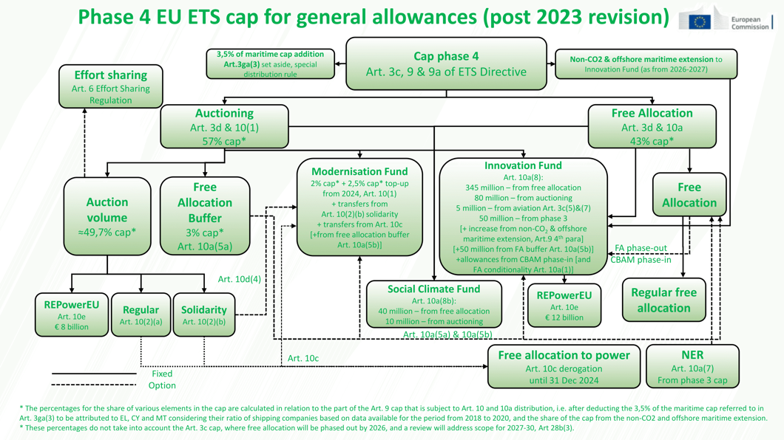
Figure 1. EU ETS Emissions Cap (European Commission. (n.d.))
This approach has gained renewed relevance due to the rapid evolution of carbon pricing and carbon dioxide removal markets in progressive jurisdictions. In compliance markets such as the European Union Emissions Trading System (EU ETS) (Figure 1), tightening emissions caps and rising allowance prices are increasing the economic value of emissions reductions and removals (European Commission, 2024). Canada has similarly implemented a federal carbon pricing benchmark that raises the cost of emissions over time, creating incentives for industrial decarbonization and removal technologies (Government of Canada, n.d.).
In parallel, voluntary carbon markets are undergoing a structural shift toward high integrity carbon dioxide removal, driven by corporate demand for durable and verifiable storage. Initiatives such as Frontier, an advance market commitment supported by major technology firms, explicitly prioritize carbon removal pathways with long term permanence and robust measurement, reporting, and verification (MRV) (Frontier, 2022). In this context, mineral carbonation in mine tailings stands out as a credible and scalable option for generating durable carbon removal credits while simultaneously improving mine waste management.

II. Who is doing this now
Several mining and mining adjacent actors have moved carbon mineralization from theory into field measurement, demonstration planning, and commercial offtake. At BHP’s Mount Keith nickel operation in Western Australia, Wilson et al. (2014) quantified atmospheric carbon dioxide capture occurring directly in ultramafic mine tailings through the formation of hydrated magnesium carbonates, establishing one of the most cited real-world demonstrations of passive mineralization at industrial scale (Power et al., 2013).
In British Columbia, Canada, experimental work on the Baptiste deposit by Power et al. (2020) provides a second major anchor case by quantifying direct air capture rates and testing enhancement pathways, including aeration and carbonation using carbon dioxide rich gas, with order of magnitude estimates for annual offsets at the scale of a proposed tailings facility (Power et al., 2013). FPX Nickel has also described a dedicated carbon capture and storage effort through CO2 Lock, positioning mineralization as a pathway to permanently mineralize carbon dioxide in settings analogous to its Baptiste project geology.
De Beers has pursued mineral carbonation research in kimberlite residues under the CarbonVault framing, emphasizing that kimberlite can react with atmospheric carbon dioxide to form stable carbonates and that mine residues can be treated as long-lived carbon storage materials. Finally, commercial demand for durable removals has begun to validate the market case: Arca announced a ten-year offtake agreement with Microsoft for nearly 300,000 tonnes of durable carbon dioxide removal delivered through industrial mineralization using mine waste (Arca, 2025).

III. How Tailings Based Carbon Mineralization Works
1. Geochemical basis: Ultramafic rocks are dominated by magnesium rich silicate minerals such as serpentine and olivine and may also contain highly reactive phases such as brucite. When these rocks are crushed and processed during mining, the resulting tailings have high surface area and increased exposure to air and water.
CO₂ + Mg-silicate + weathering → Mg-carbonate (solid)
Under these conditions, magnesium bearing minerals can react with carbon dioxide to form solid carbonate minerals, permanently immobilizing the carbon in mineral form (Lackner et al., 1995; Wilson et al., 2014).
2. Passive versus engineered pathways: Carbon mineralization can occur passively through natural weathering or be enhanced through engineered interventions. Passive mineralization has been documented at operating nickel mines, most notably at the Mount Keith mine in Western Australia, where isotopic and mineralogical analyses demonstrate significant uptake of atmospheric carbon dioxide into hydrated magnesium carbonates within the tailings facility (Wilson et al., 2014). Engineered enhancement aims to increase reaction rates and overall carbon uptake by modifying tailings management practices. These enhancements may include aeration to improve gas exchange, moisture control to sustain reactive conditions, or exposure to carbon dioxide rich gas streams. At the Baptiste nickel project in British Columbia, experimental and modelling work indicates that relatively modest engineering interventions could increase annual carbon uptake many fold compared to baseline weathering rates (Power et al., 2020).
3. Durability and MRV advantage: Mineral carbonates are stable solids. This matters for carbon markets because long-term permanence is a core criterion for high durability carbon dioxide removal. Durable storage also supports more credible measurement, reporting, and verification (MRV), because carbon can be quantified through mineralogical tests and mass balance approaches rather than relying only on modelled biological sequestration. On the standards side, methodologies are emerging that explicitly target engineered carbonation of mineral waste, including mining waste, to quantify removals from enhanced mineralization (Verra, n.d.).

IV. Requirements for Implementation at Nickel Mines
Not all mining operations are suitable candidates for tailings-based carbon mineralization. Several conditions must be met for the approach to be technically and economically viable.
First, tailings mineralogy must include sufficient quantities of reactive magnesium bearing phases. Research on the Baptiste deposit highlights the importance of brucite content in enabling rapid carbonation and higher overall sequestration potential (Power et al., 2020).
Second, large volumes of tailings and sustained exposure of reactive surfaces are necessary to achieve meaningful annual removal rates. Tailings management systems must therefore be designed to minimize surface passivation and maintain permeability over time.
Third, appropriate water and gas transport conditions are required to support carbonation reactions. In some settings, engineered delivery of carbon dioxide or controlled irrigation may be needed to overcome diffusion limits and sustain reaction kinetics.
Fourth, projects must implement robust MRV frameworks to demonstrate additionality, quantify net removals, and avoid double counting. Emerging methodologies for engineered carbonation provide a foundation, but site-specific monitoring strategies remain essential.
Finally, economic viability depends on sufficient carbon pricing or offtake value to justify investment in enhancement and monitoring. High durability carbon removal credits currently command significantly higher prices than conventional offsets, reflecting their permanence and verification advantages (Frontier, 2022).

V. Benefits and Projected Impacts
1. Climate benefits and quantified removal potential: The primary climate benefit of tailings based mineral carbonation is durable carbon dioxide removal via conversion of carbon dioxide into stable carbonate minerals. In contrast with many avoidance credits, mineralization stores carbon in a solid mineral phase with extremely low reversal risk on human timescales, which is why it is increasingly grouped with high durability removal pathways (Power et al. (2020)). The climate value of tailings mineralization can be expressed as a mass balance problem with two components: net onsite reduction in a mine’s effective footprint through direct air capture and mineralization within tailings, plus the creation of independently transferable removal credits when MRV and additionality requirements are met.
A well-documented real world passive example is Mount Keith. Wilson et al. (2014) report that hydrated magnesium carbonate formation in Mount Keith tailings corresponds to atmospheric carbon dioxide uptake on the order of 39,800 tonnes of carbon dioxide per year, which they interpret as a meaningful fraction of mine emissions under the conditions evaluated. This result is important because it establishes that passive mineralization is not merely theoretical; it is measurable at the landscape scale at an active nickel operation.
For the Baptiste deposit, Power et al. (2020) provide explicit experimental and extrapolated estimates that can be used to quantify potential annual removals under different management assumptions. They report an experimental direct capture rate of 3.5 kilograms of carbon dioxide per square meter per year, which extrapolates to roughly 17 kilotons per year when scaled to a proposed 5 square kilometre tailings facility under year-round reaction assumptions. They further report that aeration could increase effective uptake by roughly five times to 19 kilograms of carbon dioxide per square meter per year, corresponding to roughly 95 kilotons of carbon dioxide per year at the same facility scale (Power et al. (2020)). Finally, they estimate that carbonation using a 10 percent carbon dioxide gas stream could achieve offsets up to about 210 kilotons of carbon dioxide per year under their experimental assumptions, corresponding to a large fraction of projected mine emissions in their scenarios.
These values also allow an explicit scaling argument for sector relevance. Power et al. (2020) note that global production across several commodities generates on the order of 419 million tonnes of ultramafic and mafic tailings annually, indicating large potential feedstock availability for enhanced weathering and carbonation approaches if MRV and economics permit.
2. Economic value and credit revenue ranges: The financial value of carbon removal depends on carbon prices or offtake prices. Frontier reports current offtake prices across durable carbon removal pathways with an average and a range that can be used for reasonable bounding calculations. In its purchasing perspectives materials, Frontier reports an average offtake price of roughly 328 dollars per tonne with a stated price range of roughly 214 to 690 dollars per tonne for contracted removals in the pathway categories it tracks.
Using those values as a pricing envelope for durable removals, passive and enhanced mineralization at nickel tailings can be translated into revenue magnitude. If Mount Keith scale removal of 39,800 tonnes of carbon dioxide per year were creditable and sold at 214, 328, or 690 dollars per tonne, gross credit revenue would be approximately 8.5 million, 13.1 million, or 27.5 million dollars per year, respectively. For Baptiste scale estimates, 17 kilotons per year implies roughly 3.6 million, 5.6 million, or 11.7 million dollars per year at the same three prices, while the aerated scenario of 95 kilotons per year implies roughly 20.3 million, 31.2 million, or 65.6 million dollars per year. The carbon dioxide rich gas scenario of 210 kilotons per year implies roughly 44.9 million, 68.9 million, or 144.9 million dollars per year (Frontier, 2022).
These calculations should be interpreted as gross revenue bounds rather than profit. Real net benefit depends on enhancement costs, MRV costs, buffer pool or reversal provisions in the standard, and any discounting imposed by credit buyers based on perceived uncertainty. Even so, the revenue magnitudes are large enough to matter for mine economics and for long horizon reclamation funding in many jurisdictions.
3. Ecological and tailings risk reduction co benefits: Tailings carbonation can produce ecological co benefits by altering tailings mineralogy, surface chemistry, and physical properties. Carbonate precipitation can reduce the availability of reactive magnesium hydroxides and may reduce the propensity for dust generation through partial cementation of fine materials. In addition, improved geochemical stability may reduce acid generation risk in cases where carbonate formation buffers pore waters or reduces reactive surface exposure. The degree of acid mine drainage reduction is site specific and depends strongly on sulphide content, oxygen transport, and hydrology, but the core mechanism is that carbonate formation can increase buffering capacity and reduce harmful leaching pathways relative to unmanaged tailings under some conditions.
4. Community and distributional benefits with measurable pathways: Carbon revenue is most socially meaningful when it is contractually linked to long term obligations that communities experience, such as water treatment, monitoring, and closure assurance. A simple measurable pathway is to earmark a defined share of annual carbon removal revenue into a reclamation trust or community benefit agreement fund that persists through closure. For example, if a project achieved 95 kilotons of carbon dioxide removal per year and sold removals at the Frontier average of roughly 328 dollars per tonne, gross revenue would be about 31.2 million dollars per year, and even a 10 percent allocation could yield about 3.1 million dollars per year for local monitoring, remediation workforces, or closure assurance. This type of structure is quantifiable, auditable, and directly tied to a durable public good (Frontier, 2022).
5. Benefits for firms and Global Outlook: For firms, the benefit stack includes reputational and permitting value plus direct revenue. The commercial reality of durable removal demand is evidenced by Microsoft’s long-term agreement with Arca for nearly 300,000 tonnes of durable carbon dioxide removal delivered via industrial mineralization using mine waste (Arca, 2025). At the policy level, tightening compliance markets such as the EU ETS illustrate that carbon pricing is not static and can become more stringent over time, reinforcing incentives for decarbonization and credible removal supply chains (Power, 2013).
At a global level, the scale potential is driven by the large annual production of ultramafic and mafic tailings and by the compatibility of enhancement with existing mining infrastructure. The largest barriers are therefore not only geochemistry, but also MRV standardization, cost of enhancement relative to credit prices, and governance structures that ensure benefits are shared rather than captured.
VI. Implications for the Future of Mining
Carbon mineralization has the potential to reshape incentives within the mining industry. Tailings facilities could be designed not solely for containment, but also for controlled geochemical performance. Because carbonation can continue after mine closure, firms would face stronger incentives for long term monitoring and maintenance, countering historical patterns of underfunded remediation.
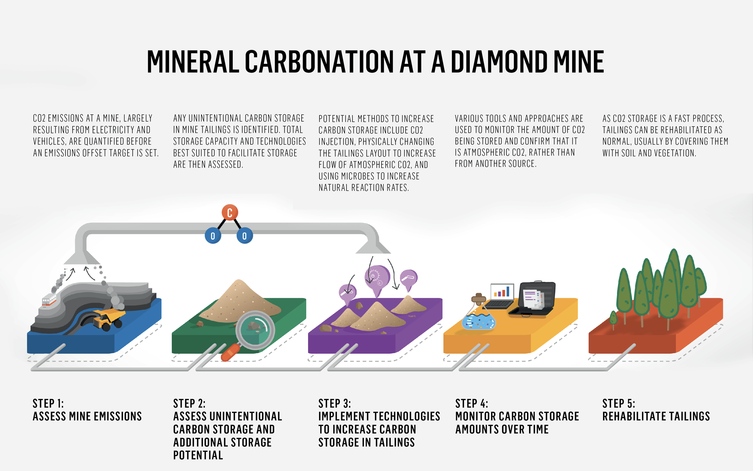
Figure 2. Mineral Carbonation at a Diamond Mine (De Beers Group. (2017))
Moreover, if carbon revenues are linked to community governance structures, mineralization projects could encourage deeper engagement and shared decision making. In this framing, nickel mines become dual purpose infrastructure: supplying critical transition metals while also delivering measurable climate benefits through durable carbon dioxide removal. While this approach does not eliminate the environmental and social risks of mining, it offers a pathway to meaningfully reduce them while aligning extraction with global climate objectives.

References
1. Arca Climate Technologies Inc. (2025). Arca announces agreement with Microsoft for durable carbon removal. Chrome-extension://efaidnbmnnnibpcajpcglclefindmkaj/https://arcaclimate.com/wp-content/uploads/2025/10/Arca-Press-Release-MSFT-offtake-29-October-2025.pdf
2. European Commission. (2024). EU emissions trading system (EU ETS). https://climate.ec.europa.eu
3. Frontier. (2022). An advance market commitment to accelerate carbon removal. https://frontierclimate.com/writing/launch
4. Government of Canada. (n.d.). Carbon pollution pricing benchmark. https://www.canada.ca/en/environment-climate-change/services/climate-change/pricing-pollution-how-it-will-work/carbon-pollution-pricing-federal-benchmark-information.html
5. Lackner, K. S., Wendt, C. H., Butt, D. P., Joyce, E. L., & Sharp, D. H. (1995). Carbon dioxide disposal in carbonate minerals. Energy, 20(11), 1153–1170. https://www.sciencedirect.com/science/article/abs/pii/036054429500071N
6. Power, I. M., Dipple, G. M., Bradshaw, P. M. D., & Harrison, A. L. (2020). Prospects for CO₂ mineralization and enhanced weathering of ultramafic mine tailings from the Baptiste nickel deposit in British Columbia, Canada. International Journal of Greenhouse Gas Control, 94, 102895. https://www.researchgate.net/publication/339605557_Prospects_for_CO2_mineralization_and_enhanced_weathering_of_ultramafic_mine_tailings_from_the_Baptiste_nickel_deposit_in_British_Columbia_Canada
7. Verra. (n.d.). Methodology for engineered carbonation of mineral waste. https://verra.org/methodologies/methodology-for-engineered-carbonation-of-mineral-waste/
8. Wilson, S. A., Harrison, A. L., Dipple, G. M., Power, I. M., Barker, S. L. L., Mayer, U., & Southam, G. (2014). Offsetting CO₂ emissions by air capture in mine tailings at the Mount Keith Nickel Mine, Western Australia. International Journal of Greenhouse Gas Control, 25, 121–140.
chrome-extension://efaidnbmnnnibpcajpcglclefindmkaj/https://static1.squarespace.com/static/5806b872ff7c50adea9acb25/t/5869be996b8f5b18108a85d2/1483325146380/Wilson+et+al%2C+2014+-+Int+J+Greenhouse+Gas+Control.pdf
9. European Commission. (n.d.). EU ETS emissions cap. European Commission. https://climate.ec.europa.eu/eu-action/carbon-markets/eu-emissions-trading-system-eu-ets/eu-ets-emissions-cap_en
10. De Beers Group. (2017). De Beers Group carbon storage research project: Fact sheet. De Beers Group. chrome-extension://efaidnbmnnnibpcajpcglclefindmkaj/https://www.debeersgroup.com/~/media/Files/D/De-Beers-Group/documents/company-news/2017/fact-sheet-carbon-storage-research-project.pdf
11. Power, I. M., McCutcheon, J., Harrison, A. L., Wilson, S. A., & Dipple, G. M. (2013). Carbon mineralization: From natural analogues to engineered systems. Reviews in Mineralogy and Geochemistry, 77(1), 305–360. https://www.researchgate.net/publication/259366665_Carbon_Mineralization_From_Natural_Analogues_to_Engineered_Systems

